**Project Title: Fraud Detection and Prevention**

**Aim**

The Fraud Detection and Prevention dashboard aims to provide insights into various metrics related to fraud detection and prevention. It helps in identifying trends, patterns, and anomalies by visualizing transaction volumes, customer demographics, geographic distribution, and fraud detection metrics. The goal is to support data-driven decisions in enhancing fraud detection and minimizing fraudulent activities.

**Features**

The dataset includes the following columns and data types:

* **CustomerID**: Unique identifier for each customer.
* **Age**: Numerical, representing the age of the customer.
* **Gender**: Categorical, representing the gender of the customer (Male/Female).
* **Income**: Numerical, representing the annual income of the customer.
* **SpendingPattern**: Categorical, indicating the spending pattern of the customer (Low, Medium, High).
* **ProductUsageFrequency**: Numerical, representing how frequently the customer uses the product.
* **LifetimeValue**: Numerical, representing the total value of the customer over their lifetime.
* **GeographicRegion**: Categorical, representing the geographic region of the customer (North, South, East, West).
* **FraudIncidentsDetected**: Numerical, representing the number of fraud incidents detected.
* **FraudDetectionAccuracy**: Numerical, representing the accuracy of fraud detection.
* **TransactionVolumes**: Numerical, representing the total volume of transactions.
* **FalsePositiveRates**: Numerical, representing the rate of false positive fraud detections.
* **FraudLossAmounts**: Numerical, representing the total amount lost due to fraud.
* **FraudResponseTimes**: Numerical, representing the response times to fraud incidents.
* **SARCounts**: Numerical, representing the number of suspicious activity reports.
* **FraudPreventionMeasuresImplemented**: Numerical, representing the number of fraud prevention measures implemented.

**Methodology**

1. **Data Cleaning and Preparation**: Ensure that the dataset is clean, with no missing or inconsistent values. Handle missing values, remove outliers, and recode categorical values where necessary.
2. **Create 'Age Group' Column**: Group ages into categories such as '18-30', '31-45', '46-60', '61-75', '76+' for more granular analysis.
3. **Visualizations**: Create various charts to visualize the data:
   * Transaction Volumes Over Age (Line Chart)
   * Income vs. Lifetime Value (Scatter Plot)
   * Count of CustomerID (Card)
   * Average of Fraud Detection Accuracy (Card)
   * Fraud Incidents Detected and Fraud Detection Accuracy by Response Times (Line and Clustered Column Chart)
   * Fraud Detection Accuracy by Response Times (Line Chart)
   * Distribution of Spending Patterns (Bar Chart)
   * Distribution of Age (Histogram)
   * Gender Distribution (Pie Chart)
   * Geographic Distribution of Customers (Filled Map)

**Output**

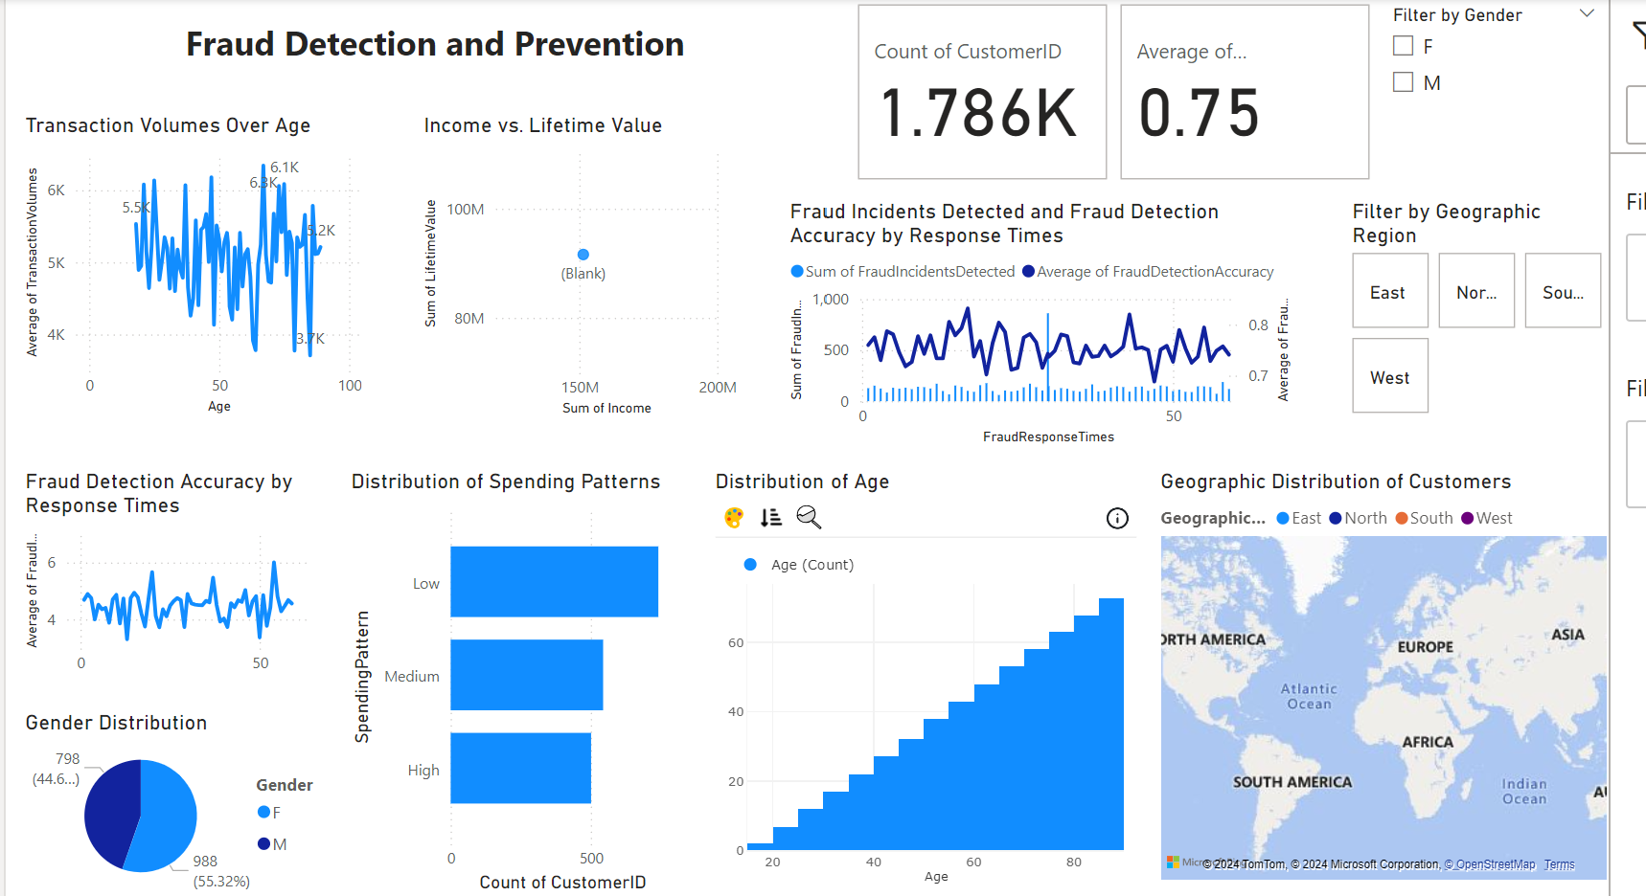

**Result Analysis**

1. **Transaction Volumes Over Age**: This line chart shows the average transaction volumes across different age groups. Peaks and valleys indicate changes in transaction volumes at different ages, with a notable peak around age 50.
2. **Income vs. Lifetime Value**: The scatter plot displays the relationship between customers' income and their lifetime value. It reveals that higher-income customers tend to have higher lifetime values.
3. **Count of CustomerID**: This card shows the total number of customers, providing a quick overview of the dataset size.
4. **Average of Fraud Detection Accuracy**: This card shows the average accuracy of fraud detection, which is 75%, indicating that the system correctly identifies fraud 75% of the time.
5. **Fraud Incidents Detected and Fraud Detection Accuracy by Response Times**: This chart shows both the sum of fraud incidents detected and the average fraud detection accuracy over different response times. It helps to see if quicker response times correlate with higher detection accuracy.
6. **Fraud Detection Accuracy by Response Times**: This line chart focuses solely on how fraud detection accuracy varies with response times, indicating consistent trends or fluctuations.
7. **Distribution of Spending Patterns**: This bar chart shows the number of customers with different spending patterns, helping to understand the distribution of spending behaviors.
8. **Distribution of Age**: The histogram displays the distribution of customers' ages, providing a demographic overview.
9. **Gender Distribution**: This pie chart shows the distribution of genders in the customer base, indicating a slightly higher proportion of male customers.
10. **Geographic Distribution of Customers**: This filled map visualizes the geographic distribution of customers across different regions, helping to see which regions have higher concentrations of customers.

**Summary of Analysis**

The Fraud Detection and Prevention dashboard provides valuable insights into the dataset, highlighting trends and patterns related to fraud detection. By analyzing transaction volumes, customer demographics, and fraud metrics, the dashboard supports data-driven decisions to enhance fraud detection and minimize fraudulent activities. Each visualization offers a unique perspective, contributing to a comprehensive understanding of the data and helping to identify areas for improvement in fraud prevention strategies.